GETTING STARTED...


A Guide for the Building Process

Town of Hotchkiss

Ronald Stoneburner, Building Official/Inspector

276 West Main Street
Hotchkiss, CO 81419
Phone: 970-872-3663
Email: buildinginspector@townofhotchkiss.com

Building permits may be required for your construction projects and can be obtained at Hotchkiss Town Hall or in .PDF format on the town of Hotchkiss Website (townofhotchkiss.colorado.gov). It is recommended that applicants schedule a conference with the Building Official.

Where do I begin?

- Determine if you need a permit and if a permit is needed go to town hall and...

  - Fill out a building permit application

  - Submit two sets of plans, plus a plot plan

  - Obtain a permit inspection card and post it at the project location.

Work exempt from permit requirements:

- Detached accessory buildings less than 120 square feet.

- Fences not over 6 feet from finish grade.

- Retaining walls that are below 4 feet in height measured from the bottom of the footing to the top of the wall.

- Water tanks supported directly upon grade if the capacity does not exceed 5,000 gallons and the ratio of height to diameter or width does not exceed 2 to 1.

- Sidewalks and driveways not more than 30 inches above adjacent grade and not over any basement or story below.

- Painting, papering, tiling, carpeting, cabinets, counter tops, and similar finish work.

- Prefabricated swimming pools that are less than 24 inches deep that do not exceed 5,000 gallons and are installed entirely above ground.

- Shade cloth structures constructed for nursery or agricultural purposes and not including service systems.

- Swings and other playground equipment accessory to a one or two- family dwelling.

- Window awnings supported by an exterior wall.

- Re-siding of buildings with same materials as original.

Work exempt from permit requirements continued…

- Uncovered patio porches, and decks less than 18 inches above ground and less than 25 sq. ft.

- Window replacement (In unaltered openings and where safety glazing is not required).

Building requirement reminders from the Town of Hotchkiss

We use the 2018 International Residential Code and the 2018 International Building Code as adopted by the municipality.

Items we do not want to miss while building include:

- Must meet minimum setbacks to eaves of structure

- Wind load 90MPH, Snow load = 40 lbs. per square foot (psf)

- Engineered foundation plans are not required in most areas though are recommended.

- On concrete slabs that are in heated areas, insulated sheeting with a minimum of R-2 rating shall extend a total linear distance of at least twenty-four (24) inches down from the top of the slab.

- Crawlspace and attic venting or conditioning.

- 5/8" drywall will be used in garages and under stairs.

- Crawlspace (floor) insulation minimum R-19 filling the framing cavity, unless a conditioned crawlspace with mechanical ventilation is provided.
- Exterior walls with minimum R-19 insulation.

- Emergency egress minimums on door and window openings.

- House wrap and flashing required. I.E. over windows and doors.

Building requirement reminders from the Town of Hotchkiss continued…

- Ceiling Insulation to R-38 minimum over entire occupied area.

- Bathrooms require opening window or fan.

- Smoke and Carbon Monoxide (CO) detectors per Life Safety Code.

- Safety glass is required where needed.

- A truss schedule is required. Hurricane clips or mechanical fasteners as per truss schedule (see engineered truss heading below for additional details and specifications).

- Roof flashing, drip edge, and gutters to move water away from foundation.

- Ice and water shield is required as a first course as well as in valleys.

- Yard drainage at a 6-inch drop in first 10 feet from foundation.

- Frost line depth is 24 inches from finished grade

- 5/8-inch OSB (oriented strand board) I required on all new roofs

ENGINEERED TRUSSES

Contractors/Builders will ensure that the following requirements are met:

- Trusses are to be placed as per plan and per engineered drawings that are provided by the manufacturer.

- If truss plans show "max uplift" of more than 150 pounds per square inch (psi) on any trusses designed for the structure, additional mechanical fasteners are required.

- Truss bracing is also shown on each of the designed trusses. Bracing shall be connected to adjacent trusses of similar design.

- All bracing to be installed as per engineered drawings, that must be supplied to the Building Inspector at the time of the rough framing inspection.

- Any modification or cutting of trusses is prohibited. An engineered fix must be supplied to the Building Inspector for inspection.

Building permit application required documents

- If a septic system is planned, the applicant must provide septic permit approval card that is issued by the Delta County Health Department.

- Submit two (2) sets of drawing that include (if applicable):

  - A plot plan of the project to scale.
  - Foundation layout with re-enforcement described.
  - Floor plan lay out with rooms identified.
  - Cut section of typical exterior walls that include the foundation and
dimensions.

  - Wall material and spacing, type of siding.
- Window location and size.
- Door location and size
- Roof layout and design
  - Have written approval from the Delta County Health Dept. for an Individual Sewer Disposal System (ISDS).

- After the plan review is accepted, the applicant must purchase a building permit.

- Inspection requests are required at least 24 hours in advance.

- After the second re-inspection a charge of $45.00 will be required to be paid before another inspection can occur.

- Inspections must be done within 180 days. After 180 days an extension may be requested in writing to the building inspector.

- Upon final inspection and approval of the building inspector a Certificate of Occupancy will be issued.

Required Inspections

This inspection Guide will provide you, the home owner or contractor, with information pertaining to those inspections of the construction work that are required under the 2018 International Residential Code and the 2018 International Building Codes.

Inspections Required:

- Set-backs – prior to excavation

- Foundations- prior to pouring concrete

- Roof and wall sheathing - prior to covering

- Framing inspection - done after rough electrical and plumbing has been signed off by State Inspectors

- Insulation - prior to drywall placement

- Drywall - prior to mud and taping (comer bead does not need to be installed)

- Final inspection

These inspections will be performed by the appropriate State Agencies

- Plumbing

- Gas

- Electrical

It shall be the duty of the person doing the work authorized by the permit to notify the Building Official that such work is ready for inspection. Said person shall also provide access to and means for inspection of such work.

When requests for inspections are called into Town Hall, every effort will be made to perform the requested inspection within 48 hours. If unable to do so, the party will be so notified.

Means of ingress and egress required

- Not less than one exit door shall be provided and meet the minimum dimensions of 3 feet in width and 6 feet 8 inches in height.

- There shall be a floor or landing on each side of the door. Said floor or landings shall not be more than 1.5 inches below the top of the threshold.

- The width of the landing shall not be less than the door served, and shall have a minimum dimension of 36 inches measured in the direction of travel.

- If additional steps are required, the maximum riser height shall be 7 ¾ inches and the minimum tread depth shall be 10 inches.

- The maximum difference between the greatest riser/tread, height or depth, and the smallest riser/tread, height or depth, shall not exceed 3/8 inches.

- All other egress doors do not require a landing within 1½ inches below top of threshold, as stipulated above. However, a landing may be installed.

- Standard steps may be installed that meet the requirements of same width of egress door, attached to a landing that has a minimum size of 3 foot by 3 foot.

Required Setbacks

All new residential construction, or any new structure, including accessory structures, built in residential neighborhoods shall have a minimum front setback of 25 (twenty-five feet), a minimum rear setback of 10 (ten feet) and a minimum side setback of 7½ (seven and one half feet). All setback measurements are to be measured from the actual surveyed plot property lines as established by property survey points/pins.

Note: Setbacks within town limits can vary depending on zoning. Please double check with the Town Hall for accurate information on setbacks.

Typical Foundation Examples:

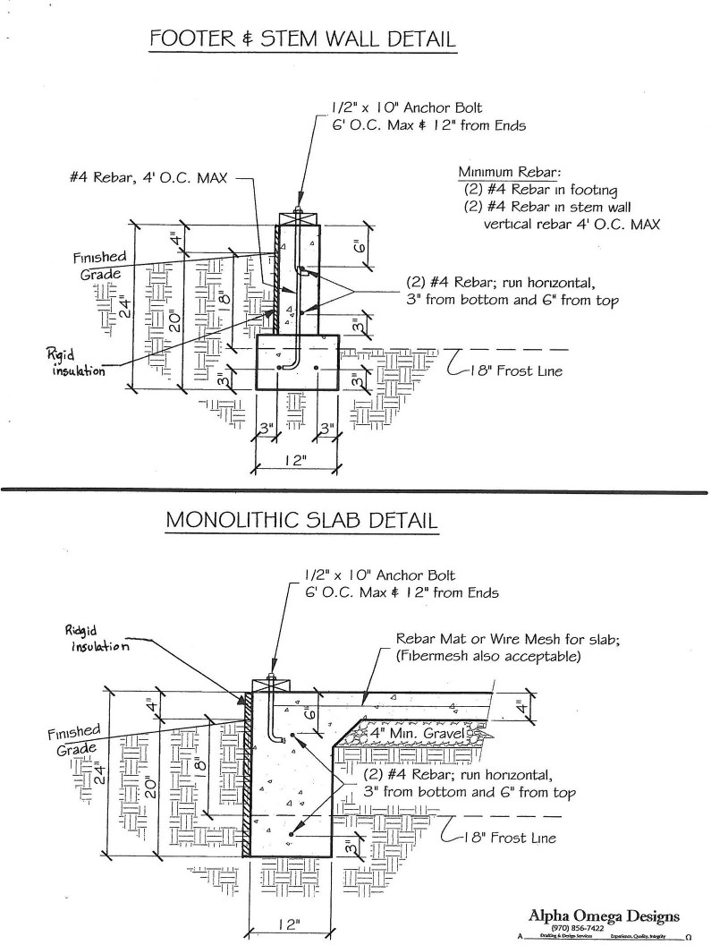

How is a permit calculated?

- Establish what is being built, and how it will be constructed (construction type)

- Use the Hotchkiss Total Valuation table provided by the Hotchkiss Town Hall Clerk’s Office to determine the cost per square foot and multiply that by the applicable square footage to compute the total valuation of the project.

- Note: Remodeling, re-roofing, fences and other similar projects may be evaluated using cost of materials or project bids to determine total valuation

- The permit fee is based on a sliding scale according to the total valuation. Please contact the Hotchkiss Town Clerk’s Office to have building permit valuations calculated for the total cost included in the building permit fee.

Town of Hotchkiss Building Permit Fees

Total Valuation | Fee
$1.00 - $500.00 | $24.00
$501.00 - $2,000.00 | $24.00 for the first $500.00 plus $3.00 for each additional $100.00, or fraction thereof. to and including $2,000.00
$2,001.00 - $40,000.00 | $69.00 for the first $2,000.00 plus $11.00  for each additional $1 000.00, or fraction thereof, to and including $40.000.00
$40,001.00 - $100,000.00 | $487.00 for the first $40,000.00 plus $9.00 for each additional $1,000.00 or fraction thereof, to and including $100,000.00
$100,001.00 - $500,000.00 | $1027.00 for the first $100,000.00 plus  $7.00 for each additional $1 000.00, or fraction thereof, to and including  $500 000.00
$500,001.00 - $1,000,000.00 | $3827.00 for the first $500,000.00 plus  $5.00 for each additional $1,000.00 or fraction thereof, to and including  $1,000,000.00
$1,000,001.00 - $5,000,000.00 | $6327.00 for the first $1,000,000.00 plus  $3.00 for each additional $1 000.00, or fraction thereof, to and including  $5,000,000.00
$5,000,001.00 and up | $18,327.00 for the first $5,000,000.00 plus  $1.00 for each additional $1,000.00 or fraction thereof

Other Inspections and Fees
Inspections outside of normal business hours (minimum 2 hours) | $50.00 per hour ¹
Re-inspection fees assessed under provisions of Section 305.8 | $50.00 per hour ¹
Inspections for which no fee is specifically indicated (minimum½ hour) | $50.00 per hour ¹
Additional plan review required by changes, additions or revisions (minimum ½ hour) | $50.00 per hour ¹
Use of outside consultants for plan checking and inspections or both | Actual costs ²
¹Or the total hourly cost to the Town of Hotchkiss, whichever is the greatest. This cost shall include supervision, overhead, equipment, hourly wages and fringe benefits of the employees involved.
²Actual costs include administrative and overhead costs.

Manufactured Home Set Up Fee $ 39.00
(Accessory Buildings Excluded)

Important Phone Numbers

Hotchkiss Town Hall----------------------------------------- 970-872-3663

Town if Hotchkiss Bulding Official/Inspector-------- 970-872-3663
Town of Hotchkiss Police Department------------------ 970-872-3848
Delta/Montrose Electrical Association (DMEA)------ 877-687-3632
Black Hills Energy--------------------------------------------- 888-890-5554
TDS hone Service---------------------------------------------- 877-837-8372
Delta County Health Department------------------------- 970-874-2165
Delta County Sherrif’s Department----------------------- 970-874-2000
State of Colorado Plumbing Inspect-------------------- 303-894-2300
State of Colorado Electrical Inspector 303-894-2300
UNCC (Utilities Notification Center of Colorado) 811

